## Revision History

|  |  |  |  |
| --- | --- | --- | --- |
| **Date** | **Revision** | **Author** | **Changes** |
| 2021/1/12 | 1.0 | ZhangSheng | Initial version. |

## IP Description: (讲清楚IP的工作方式)

Reset and clock controller



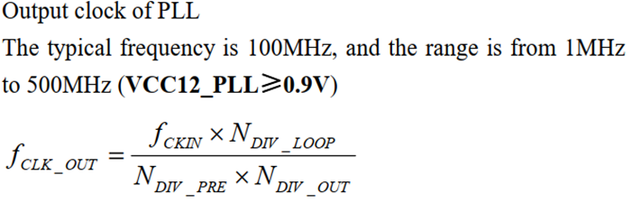

## Feature set: （功能列表）

* Reset（global reset,ahb/apb reset/enable）
* Clock（cmd,cfg）

1. HSI oscillator clock
2. HSE oscillator clock
3. PLL clock
4. Adc/usb clk config

* Misc

1. Usb phy control(USB Module)
2. DMA request（handshack）select

## Feature comparison with STM32: （跟STM32的功能比较）

**Chip-Platform:**

|  |  |  |
| --- | --- | --- |
| 符号描述：   1. ✅支持 2. ❌不支持 3. ❌硬件有，但SDK计划不支持 | AiP32RV | STM32 |
| HSE/ HSI/ LSE/ LSI（reset,cfg,cmd） | ✅ | ✅ |
| Trim/Calibrate | ✅ | ✅ |
| MISC(usb_phy_ctrl、dma_requeset_control) | ✅ | ❌ |
| MCO时钟输出 | ✅ | ✅ |
|  |  |  |

## API Design: （分类列出会实现的API, API尽量一样）

|  |  |  |
| --- | --- | --- |
|  | 103 | STM32 |
| de-init | RCC_DeInit()  Note:rcc reset 无法复位某些寄存器，需要手动reset |  |
| Config(HSE/HIS/PLL/LSI/LSE) | RCC_HSEConfig  RCC_PLLConfig  RCC_HCLKConfig  RCC_PCLK1Config  RCC_PCLK2Config  RCC_ITConfig  RCC_SYSCLKConfig  RCC_ADCCLKConfig  RCC_OTGFSCLKConfig  RCC_UartCLKConfig  RCC_MCOConfig  RCC_WaitForPllLock | RCC_HSEConfig  RCC_LSEConfig  RCC_RTCCLKConfig  RCC_PLLConfig |
| Adjust/trim | RCC_AdjustHSICalibrationValue |  |
| Cmd(EN/DIS) | RCC_HSICmd  RCC_PLLCmd  RCC_LSEConfig（放在RTC模块）  RCC_LSICmd（放在RTC模块）  RCC_APB1PeriphClockCmd  RCC_APB2PeriphClockCmd  RCC_APB2PeriphResetCmd  RCC_APB1PeriphResetCmd  RCC_AHBPeriphClockCmd  void RCC_GlobaLReset | RCC_HSICmd  RCC_LSICmd  RCC_PLLCmd  RCC_APB1PeriphClockCmd  RCC_APB2PeriphClockCmd  RCC_APB2PeriphResetCmd  RCC_APB1PeriphResetCmd  RCC_AHBPeriphClockCmd  RCC_RTCCLKCmd |
| FlagStatus | RCC_GetFlagStatus  RCC_GetITStatus  RCC_ClearITPendingBit  RCC_GetClocksFreq | RCC_ClearFlag |

## Data structure design:

typedef struct

{

    uint32_t SYSCLK_Frequency; /*!< returns SYSCLK clock frequency expressed in Hz */

    uint32_t HCLK_Frequency;   /*!< returns AHBCLK clock frequency expressed in Hz */

    uint32_t PCLK1_Frequency;  /*!< returns APBCLK1 clock frequency expressed in Hz */

    uint32_t PCLK2_Frequency;  /*!< returns APBCLK2 clock frequency expressed in Hz */

    uint32_t ADCCLK_Frequency; /*!< returns ADCCLK clock frequency expressed in Hz */

    uint32_t USART_Frequencey; /*!< returns USART clock frequency expressed in Hz */

    uint32_t USB_Frequencey;   /*!< returns USART clock frequency expressed in Hz */

} RCC_ClocksTypeDef;